Final Exam Time Series Fall 2019 / Take Home (25 points):

Due 11:59 pm Central Time Saturday, December 7

In Unit 13 we looked at an RNN model of the monthly sunspot data from 1745 to 2013 (sunspot.month in base R). This model yielded an ASE of approximately 900 when forecasting a year in advance (12 months). Your goal here will be to compare an ARMA or ARIMA model to the RNN model.

1. Stationarity: Here we will check condition 3 of a stationary process. Instead of looking at the first half versus the second half, let’s compare the timespans of fewer sunspots to the greater timespans of greater sunspots. As an example, compare the acfs (autocorrelation structure) of the highlighted timespans below (you will need to approximate the start and end times). Show your acfs and end with a statement of if you feel condition 3 is met or not.

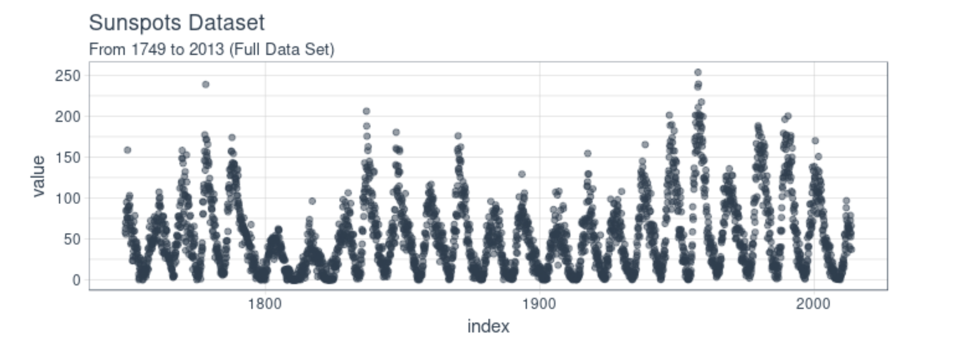

1. In the blog we reviewed in class, the author used a comprehensive resampling scheme to generate many forecasts of 12 months in order to calculate the ASE. We will not be this sophisticated or comprehensive but we will generate 3 ASEs and use the average of these ASEs to evaluate the ARMA or ARIMA model you fit. To do this, separate the data into 3 mutually exclusive sets: 1751 to 1825, 1826 to 1900, and 1901 to 1975.
2. Based on your findings and your intuition, fit a stationary or non-stationary model to each partition and use it to forecast the last 12 months of that partition (you may refit the model for each partition or use the same model… your choice). Calculate and report the ASE of each forecast and compare it to the ASE from the RNN model. Also, fully specify your model(s) in backshift notation.
3. Clearly describe why you chose the stationary or non-stationary model you chose above.

The document to turn in here will be a knit pdf or html of an RMD (with the code visible.) Try and keep your output to a reasonable length but do provide useful comments (as usual) to your code and written explanations where appropriate. Be clear but terse. Part of the grade is on your results and part of your grade is how clear and efficient you are able to communicate your analysis. To be ultra-secure, please submit this to 2DS and email it to me as well.

Great job this semester! I will see you at immersion and / or at graduation!

**Whamo!**